

**PES UNIVERSITY, BENGALURU**

Final Semester Assessment (FSA) – B. Tech, (CSE) – V Sem

Session: August – December, 2019

**UE17CS301– COMPUTER NETWORKS**

Project Report

On

“Drive Storage”

|  |  |
| --- | --- |
| NAME | SRN |
| Suman K | PES1201701549 |
| Suhas B N | PES1201701429 |
| Dheeraj D Gharde | PES1201700075 |

**Department of Computer Science & Engineering**

**PES University**

(Established under Karnataka Act No. 16 of 2013)

100 Feet Ring Road, Bengaluru – 560 085, Karnataka, India

**ABSTRACT:**

Our project comprised of building an application that enables one to store their files on a server. The user can create an account using the Command Line Interface. After creation of the account, the user now has a share of the server for himself and can add or remove files from his/her share.

**MODULES DEVELOPED:**

* Client that sends and views files
* Server that stores files

**TOPOLOGY:**

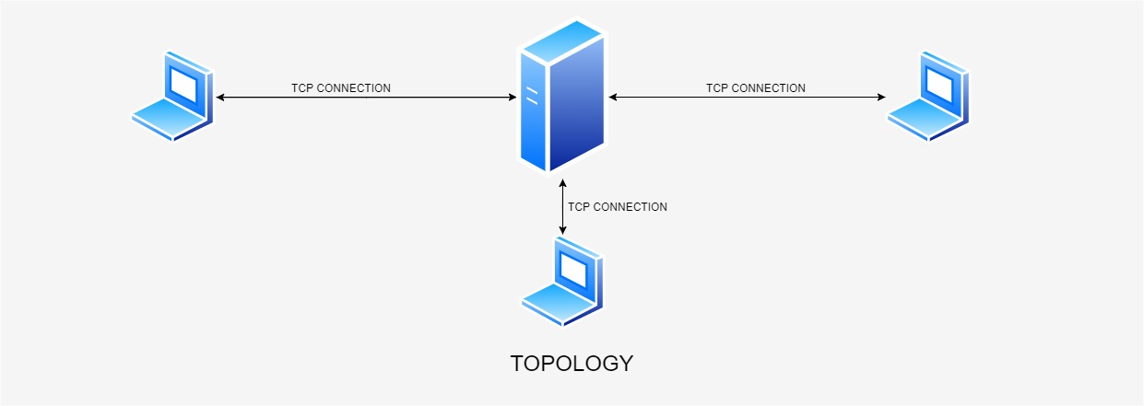

**NETWORKS CONCEPT USED:**

* Socket Programming

**NEW CONCEPT LEARNT:**

* JSON

**SAMPLE INPUT/OUTPUT:**

